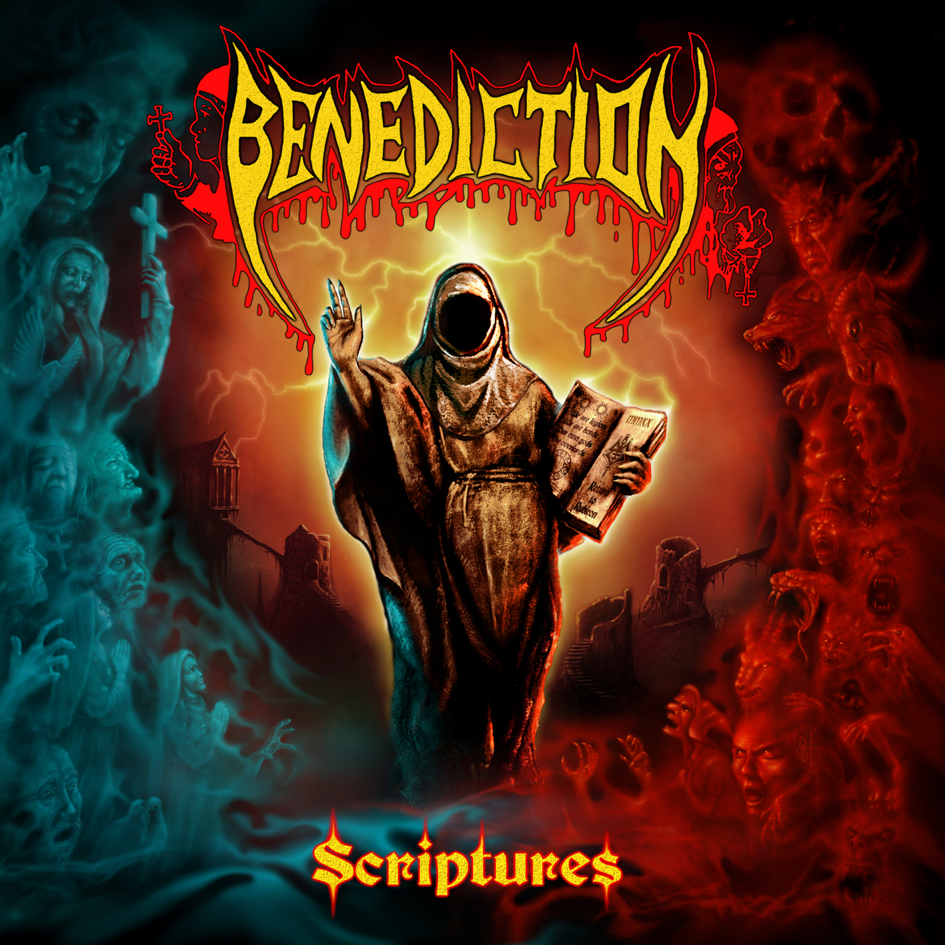

BENEDICTION
»Scriptures«

Out: October 16th 2020

Line-up: | BENEDICTION online:
Darren Brookes - guitar  Peter Rew - guitar  Dave Ingram - vocals  Dan Bate - Bass  Giovanni Durst - drums | www.facebook.com/Benedictionband  www.instagram.com/benediction_band/  https://twitter.com/benediction

At last, BENEDICTION return to the fold with a crushing new album and an equally impressive line up.

When vocalist of over 20 years Dave Hunt announced last summer that he needed time away from the band to finish his PhD, the lads decided not to sit back and wait. With Dave’s blessing, they decided to push on without him. The band were to make only one phone call.
“When Daz called me it was totally out of the blue. We chatted for a little while and then he asked me if I’d be interested in a return. As soon as he said it there was NO hesitation, I was IN!!!” recalls Dave Ingram. “It just felt so comfortable, so effortless, so right.”
Since they announced the reappointment of Ingram, Vocalist on some of BENEDICTION’s classic early releases such as ‘The Grand Leveller’, ‘Grind Bastard’ and the groundbreaking opus that is ‘Transcend the Rubicon’, often classed as one of the most influential as important death metal releases to date, attention on this cult band has gone ballistic.
“We’re not making a comeback here” says Daz Brookes (original member and mainstay along with fellow guitar player Peter Rew) “but it really feels that way with this resurgence of interest and the clamor for interviews”.

Formed in 1989, and after many years doing the rounds under other names, BENEDICTION, as we know it, was formed and the band was quickly picked up by German underground Metal label Nuclear Blast Records, a partnership that lasts to this day.
“We had lots of offers at the time, all the obvious ones, but Markus at NBR seemed to be a real fan of what we were doing and of the underground scene in general as it was then. He was one of us” Rewy recalls, “a perfect match really and we’ve never looked back”.
BENEDICTION have since gone on to release many acclaimed albums and are now recognized as one of the originals in the death metal scene. They do however continually strive to deliver the goods and are still to this day thoroughly enthused by what they do as you clearly see when they are together, especially up on stage.
“These guys obviously believe in what they are doing and it’s a great atmosphere to be around. We are all Brothers here, and I for one am relishing this opportunity,” claims Gio.
The band have constantly toured the world, playing some huge shows with many of the biggest bands in the metal world as well as embarking on numerous tours of their own. Taking with them their no nonsense, energy packed performance, BENEDICTION travel to anywhere and everywhere they can possibly go, often playing shows in places other wouldn’t dare, much to the delight of their loyal and still ever growing number of fans across the globe.

With over 30 years in this business and a genre that not only refuses to die but is benefitting from a new lease of life, BENEDICTION are back with arguably their best release to date and will no doubt secure their well earned seat at the top table once more.
All the raw power you expect from this colossal metal machine is on show. Crushing guitars from messers Rew and Brookes, vocals from Dave that sound even more powerful than back in the day, all backed up by a solid platform of concrete bass lines from Daniel Bate and a monster behind the kit in Gio Durst, surely soon to be recognized as one of the best drummers in this league.
Production was handled by Scott Atkins at Grindstone studio in England.
Bate recalls “Scott has really worked hard with us on this project and together I think we’ve managed to capture that real BENEDICTION sound. We’ve brought it right up to date, without over producing it and killing its raw edge. We’re pretty chuffed with the outcome and are confident the fans will love it too” he concludes.

The new release “Scriptures” has that typical BENEDICTION Death Metal core, fused with the punk rock anger and attitude, the heavy Metal powertrain riffing that’s become a staple for the band, aggressive monster vocal delivering meaningful lyrics to entice you in, and that groove that only BENEDICTION seem to possess that sets them out amongst the others in their field and has become a trademark of their material over the years. As usual, tracks vary from slow and heavy to fast and intense, from shorter, in your face numbers to epic masterpieces. BENEDICTION don’t follow blueprints when it comes to the parameters of writing these great tunes but you will be in no doubt who you are listening to. It is clearly and intentionally BENEDICTION. That will never change.

The artwork for this release is outstanding and very much typically BENEDICTION. Created by Birmingham artist Wolven Claws Artist, it is a throwback to the iconic early album covers the band used way back then. With vivid colors and that ‘old school’ feel, it is definitely a BENEDICTION album cover. An absolute must for collectors of vinyl or as an eye-catching poster.
All in all this album is the complete package. A solid slab of early death metal, with a modern edge to it, right up to date and there to challenge the best that’s out there today. A powerhouse release from a band that’s been there from the very beginning.
BENEDICTION are BACK! And they are better than EVER! I’m sure you will agree!

